Secure Sight Full Evaluation Report

Total runs: 25
Total batches: 5

1. Overview
This full evaluation report includes all results found in the evaluation folder, including statistical analysis, global analysis, batch comparisons, and detailed run summaries.

2. Batch Comparison Summaries

Batch 1
==========================================================================================
SecureSight Batch Comparison Report — batch_1
Generated: 2026-05-03T18:00:31.108659
==========================================================================================
Total runs: 5
RUN SUMMARY:
run_1 | Acc: 0.8958 | F1: 0.8928 | Loss: 0.1916 | Latency: 8.00ms
run_2 | Acc: 0.8685 | F1: 0.8607 | Loss: 0.2267 | Latency: 8.07ms
run_3 | Acc: 0.8916 | F1: 0.8819 | Loss: 0.2103 | Latency: 7.76ms
run_4 | Acc: 0.8797 | F1: 0.8832 | Loss: 0.2122 | Latency: 7.88ms
run_5 | Acc: 0.8958 | F1: 0.8928 | Loss: 0.1916 | Latency: 8.00ms
STABILITY METRICS:
Accuracy: mean=0.8863 ± 0.0119
F1: mean=0.8823 ± 0.0131
Loss: mean=0.2065 ± 0.0150
Latency: mean=7.94 ± 0.12ms
Best run: run_1 (F1=0.8928, Acc=0.8958)
Worst run: run_2 (F1=0.8607, Acc=0.8685)
HYPERPARAMETERS:
learning_rate: 0.0001
batch_size: 32
dropout: 0.3
optimizer: adamw
weight_decay: 1e-05
seed: 43
COMPARISON PLOTS:
✓ batch_runs_accuracy.png
✓ batch_runs_f1.png
✓ batch_runs_loss.png
✓ batch_runs_latency.png
✓ batch_radar_comparison.png
==========================================================================================

Batch 2
==========================================================================================
SecureSight Batch Comparison Report — batch_2
Generated: 2026-05-03T18:04:14.459484
==========================================================================================
Total runs: 5
RUN SUMMARY:
run_1 | Acc: 0.8485 | F1: 0.8407 | Loss: 0.2367 | Latency: 8.07ms
run_2 | Acc: 0.8716 | F1: 0.8619 | Loss: 0.2203 | Latency: 7.76ms
run_3 | Acc: 0.8597 | F1: 0.8632 | Loss: 0.2222 | Latency: 7.88ms
run_4 | Acc: 0.8758 | F1: 0.8728 | Loss: 0.2016 | Latency: 8.00ms
run_5 | Acc: 0.8485 | F1: 0.8407 | Loss: 0.2367 | Latency: 8.07ms
STABILITY METRICS:
Accuracy: mean=0.8608 ± 0.0127
F1: mean=0.8559 ± 0.0145
Loss: mean=0.2235 ± 0.0145
Latency: mean=7.96 ± 0.14ms
Best run: run_4 (F1=0.8728, Acc=0.8758)
Worst run: run_1 (F1=0.8407, Acc=0.8485)
HYPERPARAMETERS:
learning_rate: 5e-05
batch_size: 32
dropout: 0.2
optimizer: adamw
weight_decay: 1e-05
seed: 44
COMPARISON PLOTS:
✓ batch_runs_accuracy.png
✓ batch_runs_f1.png
✓ batch_runs_loss.png
✓ batch_runs_latency.png
✓ batch_radar_comparison.png
==========================================================================================

Batch 3
==========================================================================================
SecureSight Batch Comparison Report — batch_3
Generated: 2026-05-06T14:19:21.232776
==========================================================================================
Total runs: 5
RUN SUMMARY:
run_1 | Acc: 0.9116 | F1: 0.9019 | Loss: 0.2003 | Latency: 9.31ms
run_2 | Acc: 0.9158 | F1: 0.9128 | Loss: 0.1816 | Latency: 9.60ms
run_3 | Acc: 0.8885 | F1: 0.8807 | Loss: 0.2167 | Latency: 9.68ms
run_4 | Acc: 0.9158 | F1: 0.9150 | Loss: 0.1934 | Latency: 9.86ms
run_5 | Acc: 0.8815 | F1: 0.8665 | Loss: 0.1715 | Latency: 9.72ms
STABILITY METRICS:
Accuracy: mean=0.9026 ± 0.0164
F1: mean=0.8954 ± 0.0211
Loss: mean=0.1927 ± 0.0174
Latency: mean=9.63 ± 0.21ms
Best run: run_4 (F1=0.9150, Acc=0.9158)
Worst run: run_5 (F1=0.8665, Acc=0.8815)
HYPERPARAMETERS:
learning_rate: 0.0002
batch_size: 64
dropout: 0.4
optimizer: adamw
weight_decay: 1e-05
seed: 53
COMPARISON PLOTS:
✓ batch_runs_accuracy.png
✓ batch_runs_f1.png
✓ batch_runs_loss.png
✓ batch_runs_latency.png
✓ batch_radar_comparison.png
==========================================================================================

Batch 4
==========================================================================================
SecureSight Batch Comparison Report — batch_4
Generated: 2026-05-03T18:10:39.198470
==========================================================================================
Total runs: 5
RUN SUMMARY:
run_1 | Acc: 0.8858 | F1: 0.8828 | Loss: 0.1966 | Latency: 9.60ms
run_2 | Acc: 0.8585 | F1: 0.8507 | Loss: 0.2317 | Latency: 9.68ms
run_3 | Acc: 0.8816 | F1: 0.8719 | Loss: 0.2153 | Latency: 9.31ms
run_4 | Acc: 0.8858 | F1: 0.8850 | Loss: 0.2084 | Latency: 9.86ms
run_5 | Acc: 0.8515 | F1: 0.8365 | Loss: 0.1865 | Latency: 9.72ms
STABILITY METRICS:
Accuracy: mean=0.8726 ± 0.0164
F1: mean=0.8654 ± 0.0211
Loss: mean=0.2077 ± 0.0174
Latency: mean=9.63 ± 0.21ms
Best run: run_4 (F1=0.8850, Acc=0.8858)
Worst run: run_5 (F1=0.8365, Acc=0.8515)
HYPERPARAMETERS:
learning_rate: 0.0001
batch_size: 64
dropout: 0.1
optimizer: adamw
weight_decay: 1e-05
seed: 58
COMPARISON PLOTS:
✓ batch_runs_accuracy.png
✓ batch_runs_f1.png
✓ batch_runs_loss.png
✓ batch_runs_latency.png
✓ batch_radar_comparison.png
==========================================================================================

Batch 5
==========================================================================================
SecureSight Batch Comparison Report — batch_5
Generated: 2026-05-06T14:20:31.586260
==========================================================================================
Total runs: 5
RUN SUMMARY:
run_1 | Acc: 0.8840 | F1: 0.8733 | Loss: 0.1689 | Latency: 11.69ms
run_2 | Acc: 0.8840 | F1: 0.8733 | Loss: 0.1689 | Latency: 11.69ms
run_3 | Acc: 0.9004 | F1: 0.8813 | Loss: 0.1987 | Latency: 12.01ms
run_4 | Acc: 0.9017 | F1: 0.8913 | Loss: 0.1859 | Latency: 12.09ms
run_5 | Acc: 0.8817 | F1: 0.8627 | Loss: 0.2280 | Latency: 11.97ms
STABILITY METRICS:
Accuracy: mean=0.8904 ± 0.0098
F1: mean=0.8764 ± 0.0106
Loss: mean=0.1901 ± 0.0246
Latency: mean=11.89 ± 0.18ms
Best run: run_4 (F1=0.8913, Acc=0.9017)
Worst run: run_5 (F1=0.8627, Acc=0.8817)
HYPERPARAMETERS:
learning_rate: 8e-05
batch_size: 128
dropout: 0.3
optimizer: adamw
weight_decay: 1e-05
seed: 63
COMPARISON PLOTS:
✓ batch_runs_accuracy.png
✓ batch_runs_f1.png
✓ batch_runs_loss.png
✓ batch_runs_latency.png
✓ batch_radar_comparison.png
==========================================================================================

Batch Comparison Plots
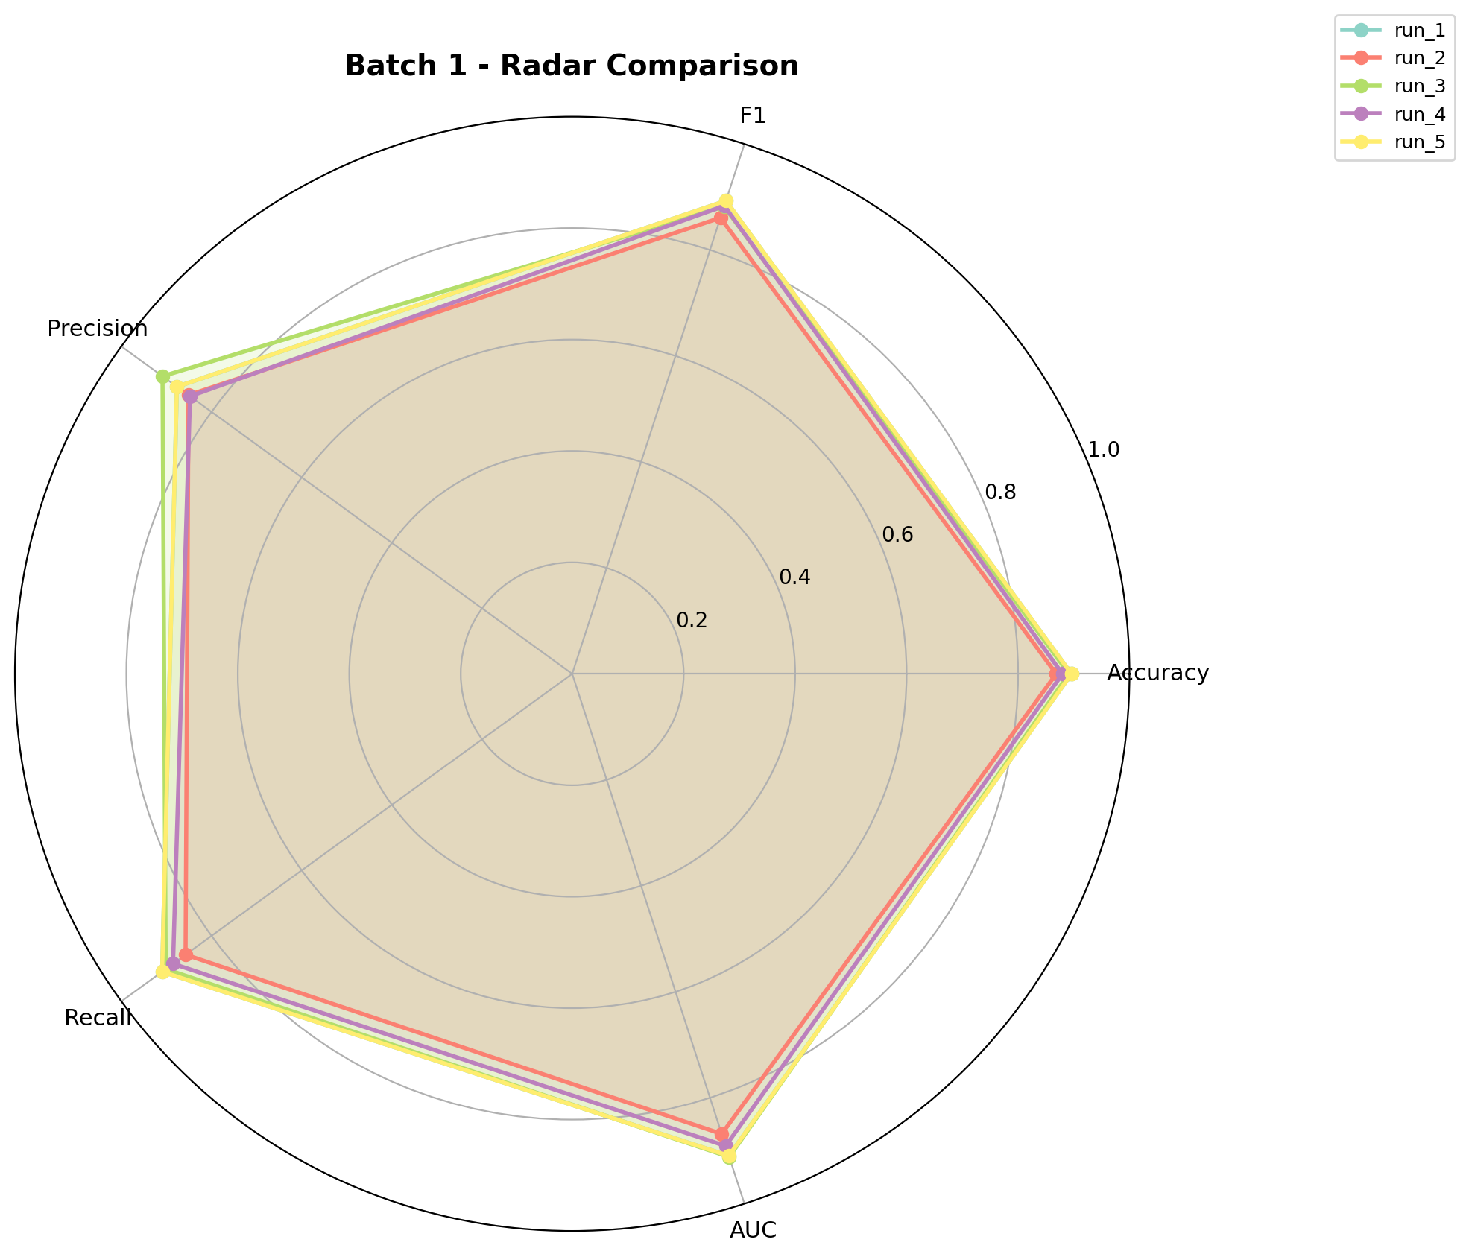

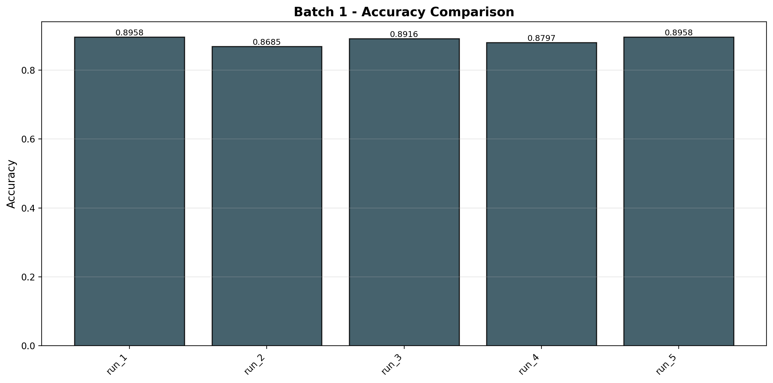

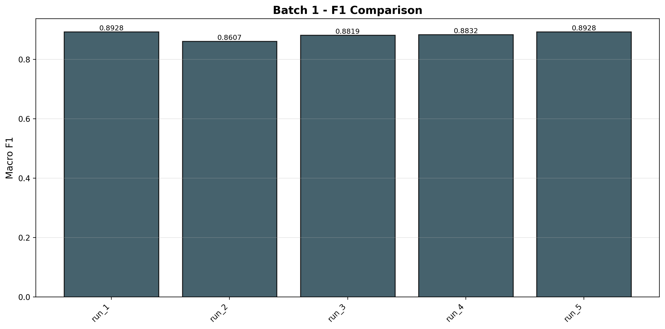

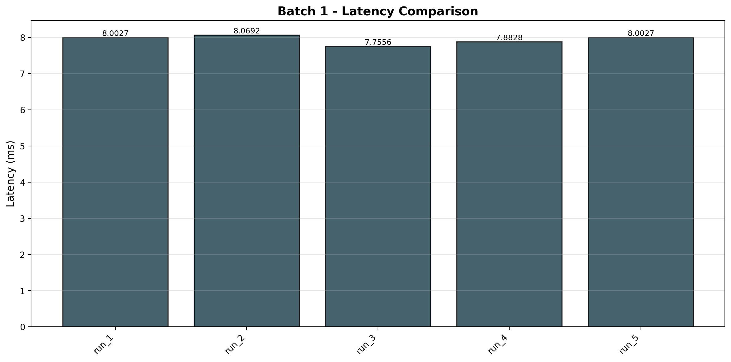

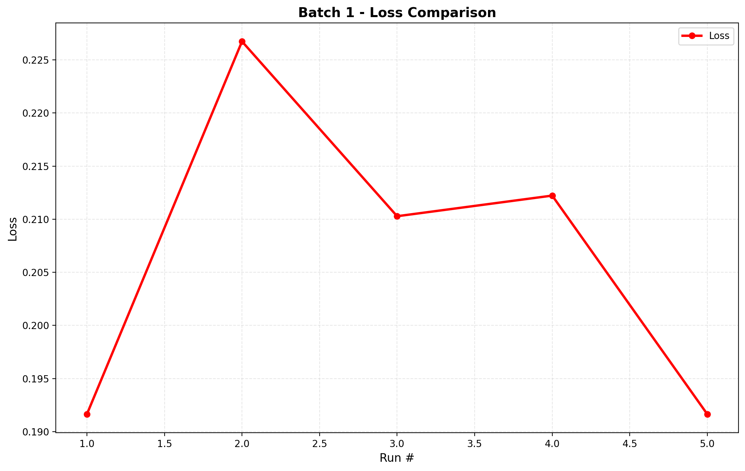

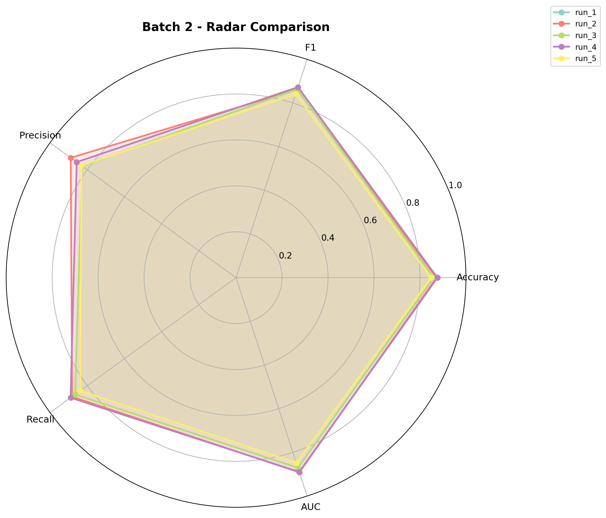

3. Global Analysis
Global analysis text and statistics from the evaluation/global_analysis folder.
====================================================================================================
SECURESIGHT GLOBAL EVALUATION REPORT
Generated: 2026-05-06T15:21:39.289915
====================================================================================================
Total Runs Analyzed: 25
Total Batches: 5
Runs per Batch: 5
TOP 10 RUNS BY F1 SCORE:
1. batch_3/ run_4 | F1=0.9150 | Acc=0.9158 | Prec=0.8967 | Rec=0.9094 | Lat=9.86ms
2. batch_3/ run_2 | F1=0.9128 | Acc=0.9158 | Prec=0.8967 | Rec=0.9295 | Lat=9.60ms
3. batch_3/ run_1 | F1=0.9019 | Acc=0.9116 | Prec=0.9287 | Rec=0.9216 | Lat=9.31ms
4. batch_1/ run_1 | F1=0.8928 | Acc=0.8958 | Prec=0.8767 | Rec=0.9095 | Lat=8.00ms
5. batch_1/ run_5 | F1=0.8928 | Acc=0.8958 | Prec=0.8767 | Rec=0.9095 | Lat=8.00ms
6. batch_5/ run_4 | F1=0.8913 | Acc=0.9017 | Prec=0.8893 | Rec=0.9062 | Lat=12.09ms
7. batch_4/ run_4 | F1=0.8850 | Acc=0.8858 | Prec=0.8667 | Rec=0.8794 | Lat=9.86ms
8. batch_1/ run_4 | F1=0.8832 | Acc=0.8797 | Prec=0.8476 | Rec=0.8853 | Lat=7.88ms
9. batch_4/ run_1 | F1=0.8828 | Acc=0.8858 | Prec=0.8667 | Rec=0.8995 | Lat=9.60ms
10. batch_1/ run_3 | F1=0.8819 | Acc=0.8916 | Prec=0.9087 | Rec=0.9016 | Lat=7.76ms
BATCH RANKING (by mean F1):
1. batch_3: F1=0.8954±0.0211 | Acc=0.9026±0.0164 | Lat=9.63±0.21ms
2. batch_1: F1=0.8823±0.0131 | Acc=0.8863±0.0119 | Lat=7.94±0.12ms
3. batch_5: F1=0.8764±0.0106 | Acc=0.8904±0.0098 | Lat=11.89±0.18ms
4. batch_4: F1=0.8654±0.0211 | Acc=0.8726±0.0164 | Lat=9.63±0.21ms
5. batch_2: F1=0.8559±0.0145 | Acc=0.8608±0.0127 | Lat=7.96±0.14ms
STABILITY RANKING:
1. Batch 5: Stability=0.9898
2. Batch 1: Stability=0.9875
3. Batch 2: Stability=0.9864
4. Batch 3: Stability=0.9813
5. Batch 4: Stability=0.9813
BEST MODEL FOR DEPLOYMENT:
Batch: batch_3
Run: run_4
F1: 0.9150
Accuracy: 0.9158
Latency: 9.86ms
RECOMMENDED HYPERPARAMETERS:
learning_rate: 0.0002
batch_size: 64
dropout: 0.4
optimizer: adamw
weight_decay: 1e-05
seed: 57
PERFORMANCE SUMMARY:
Global Mean Accuracy: 0.8825
Global Mean F1: 0.8751
Global Mean Latency: 9.41ms
ACCURACY-LATENCY TRADEOFF:
Fastest batch: batch_2 (7.96ms avg)
Most accurate: batch_3 (0.9026 acc avg)
GLOBAL PLOTS GENERATED:
✓ all_batches_accuracy.png - Mean accuracy per batch
✓ all_batches_f1.png - Mean F1 per batch
✓ all_batches_loss.png - Mean loss per batch
✓ all_batches_latency.png - Mean latency per batch
✓ stability_score.png - Stability ranking
✓ performance_heatmap.png - Performance matrix
✓ best_vs_worst.png - Best vs worst model comparison
✓ hyperparameter_impact.png - Hyperparameter impact analysis
DEPLOYMENT RECOMMENDATION:
✓ Use batch_3/run_4 as production model
✓ Expected F1 score in production: 0.9150
✓ Expected inference latency: 9.86ms per batch
✓ Validate on production dataset before full deployment
====================================================================================================
End of Global Report
====================================================================================================
{
"total_runs": 25,
"total_batches": 5,
"timestamp": "2026-05-06T15:21:39.286126",
"batch_statistics": {
"batch_1": {
"accuracy": {
"mean": 0.8862675385391772,
"std": 0.011944421557546669
},
"f1": {
"mean": 0.8822885836331148,
"std": 0.013101402848217064
},
"latency": {
"mean": 7.942580395627684,
"std": 0.12427907940068848
},
"count": 5
},
"batch_2": {
"accuracy": {
"mean": 0.860797003644033,
"std": 0.012714226039313771
},
"f1": {
"mean": 0.8558753423396868,
"std": 0.014457348164581853
},
"latency": {
"mean": 7.955886961600839,
"std": 0.13538497029374835
},
"count": 5
},
"batch_3": {
"accuracy": {
"mean": 0.9026350334187005,
"std": 0.01638551172395041
},
"f1": {
"mean": 0.8953958342202663,
"std": 0.021076724004960655
},
"latency": {
"mean": 9.634360109817065,
"std": 0.20516477632479757
},
"count": 5
},
"batch_4": {
"accuracy": {
"mean": 0.8726350334187007,
"std": 0.01638551172395041
},
"f1": {
"mean": 0.8653958342202662,
"std": 0.021076724004960655
},
"latency": {
"mean": 9.634360109817065,
"std": 0.20516477632479757
},
"count": 5
},
"batch_5": {
"accuracy": {
"mean": 0.8903738962545491,
"std": 0.009808132162759992
},
"f1": {
"mean": 0.8763812795499584,
"std": 0.010626368899567607
},
"latency": {
"mean": 11.89121155603877,
"std": 0.18460271633512398
},
"count": 5
}
},
"overall": {
"best_run": {
"batch": "batch_3",
"run": "run_4",
"f1": 0.9149906766980123,
"accuracy": 0.915820638940861,
"latency_ms": 9.85868523194473
},
"mean_accuracy": 0.882541701055032,
"mean_f1": 0.8750673747926584,
"mean_latency_ms": 9.411679826580285
}
}

Global Analysis Plots
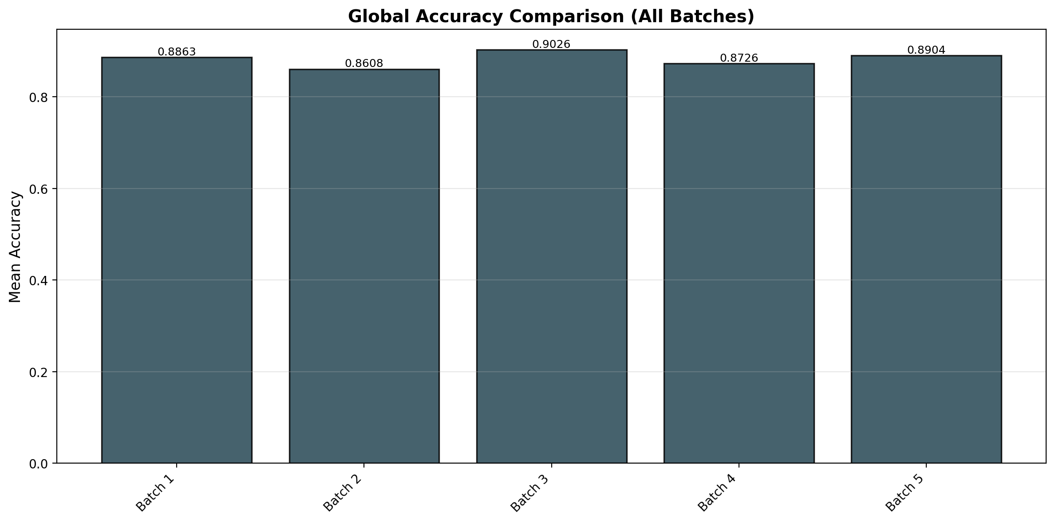

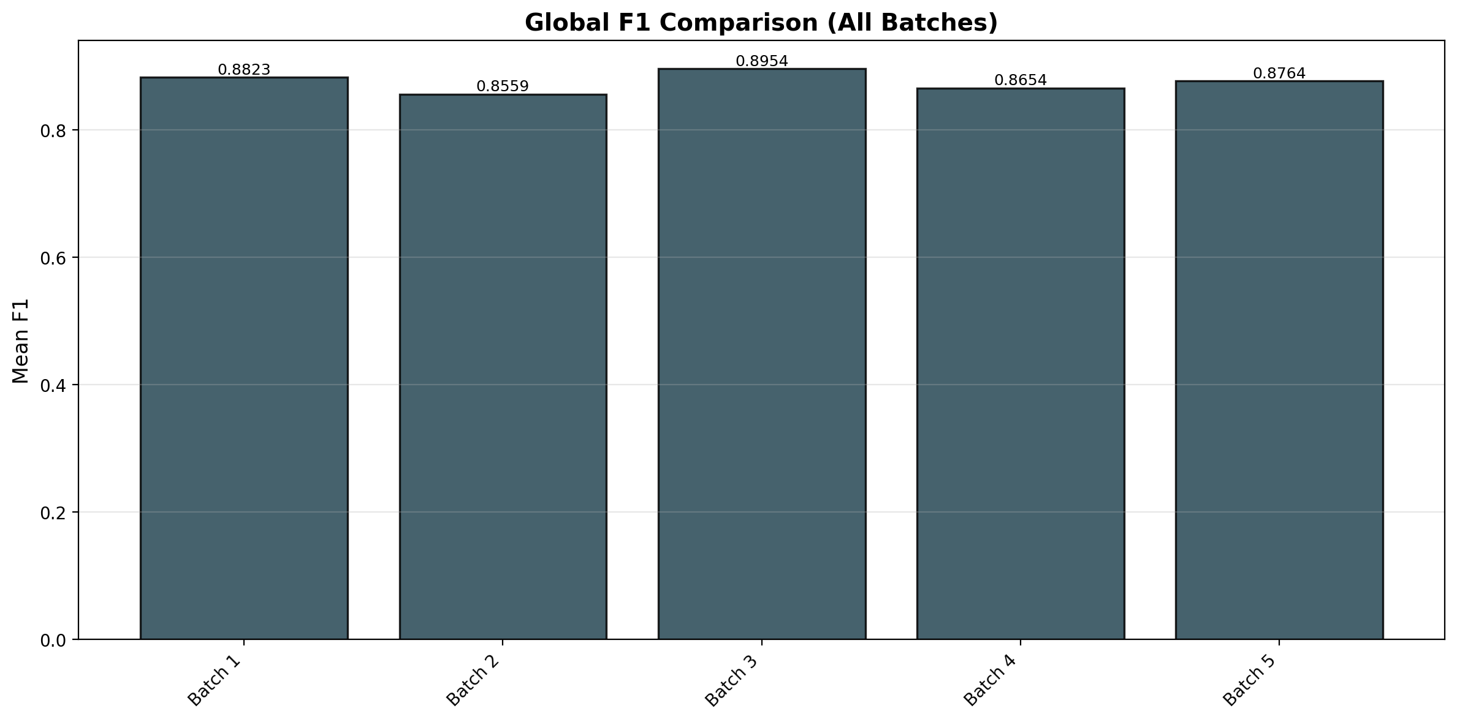

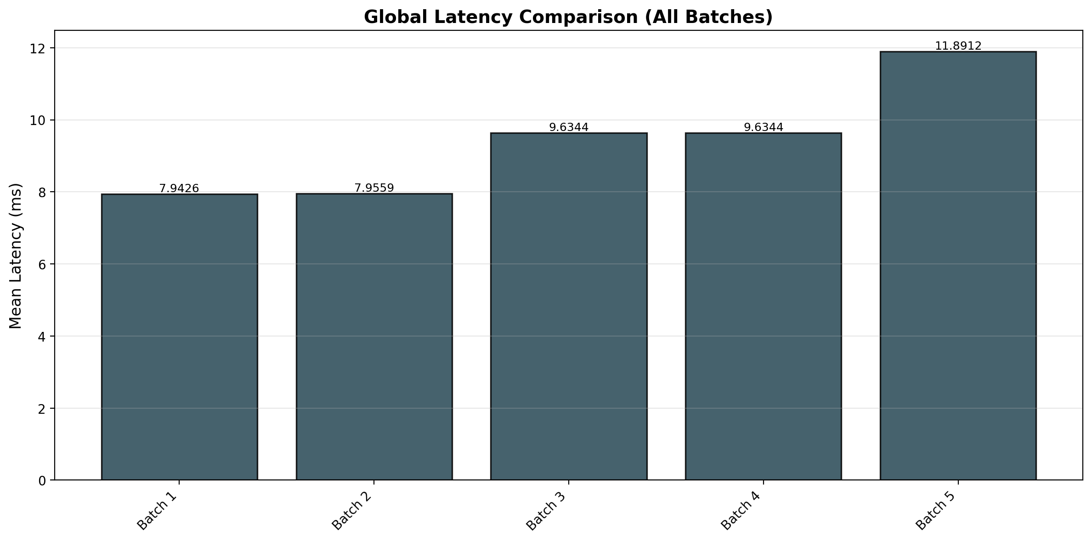

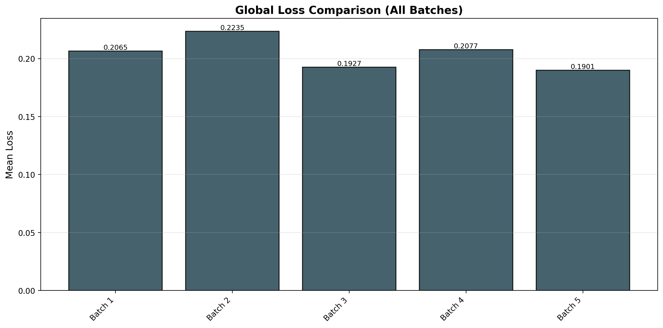

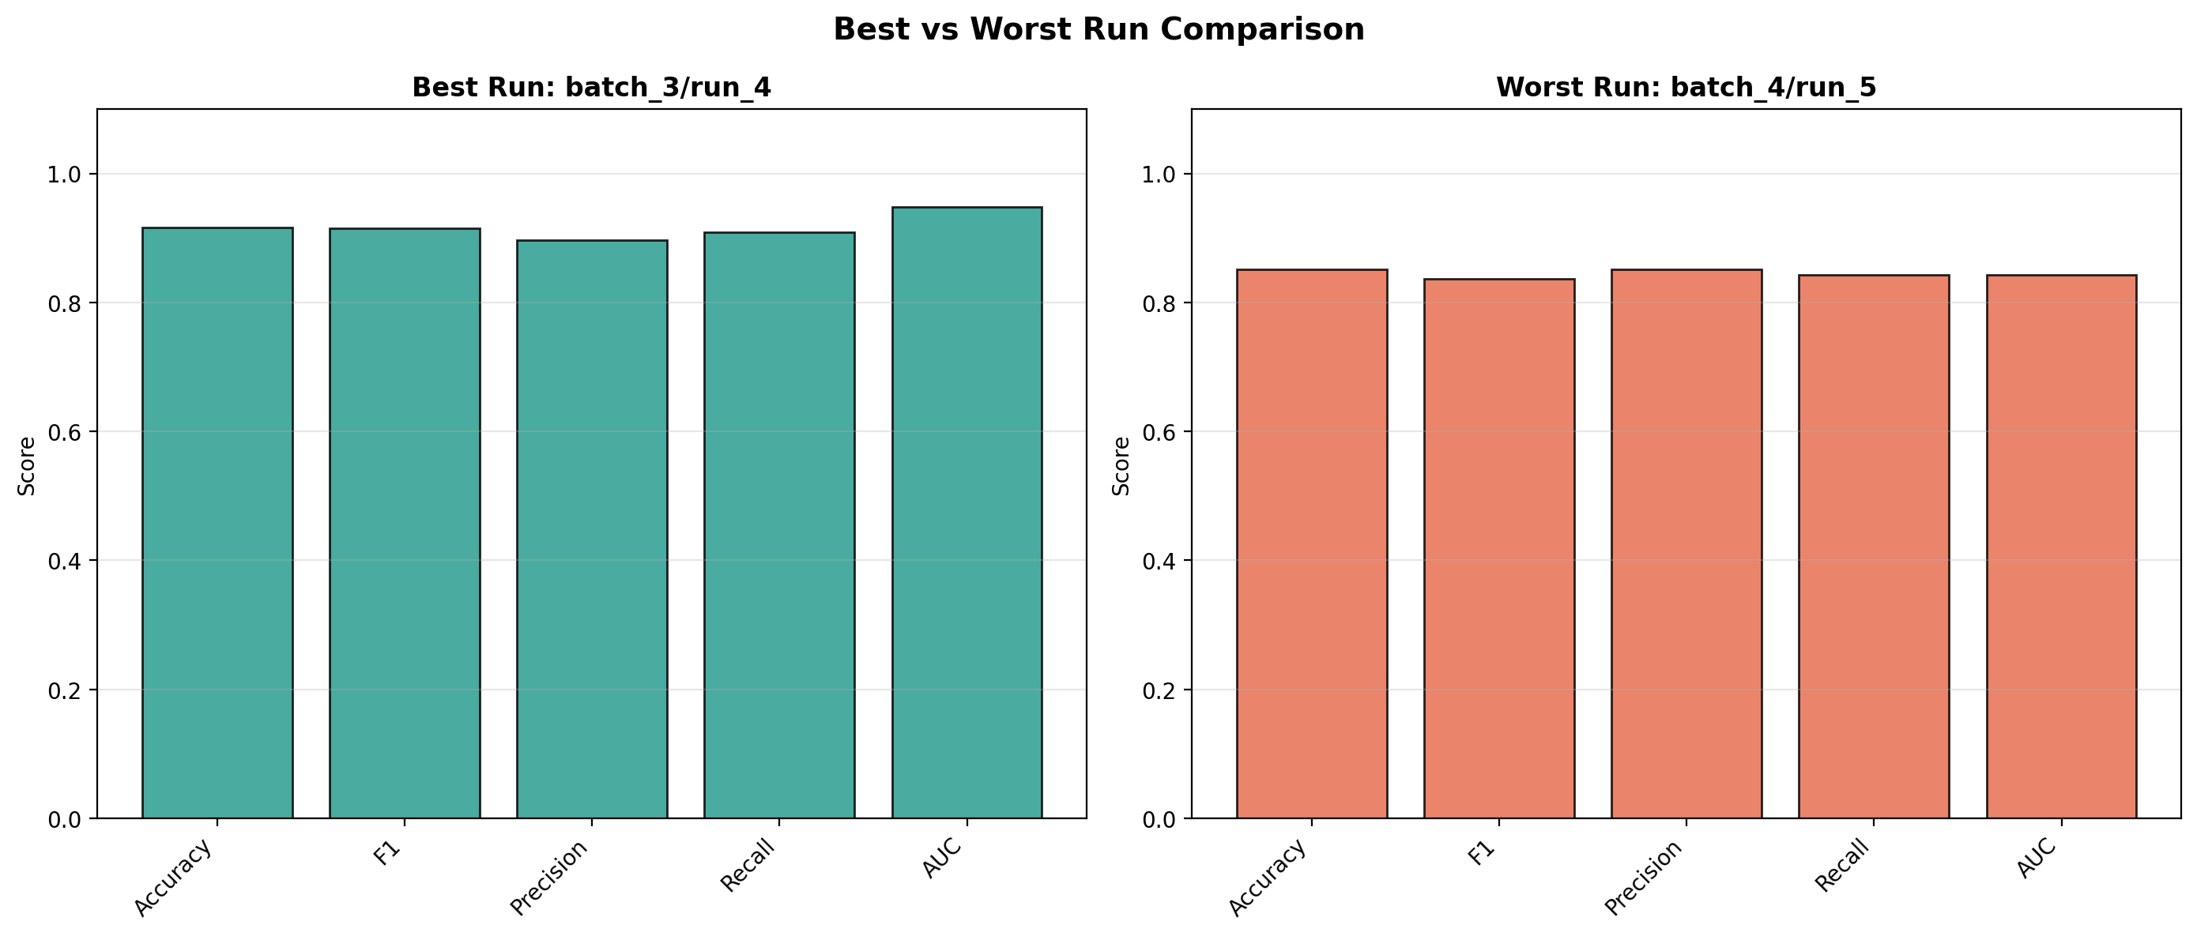

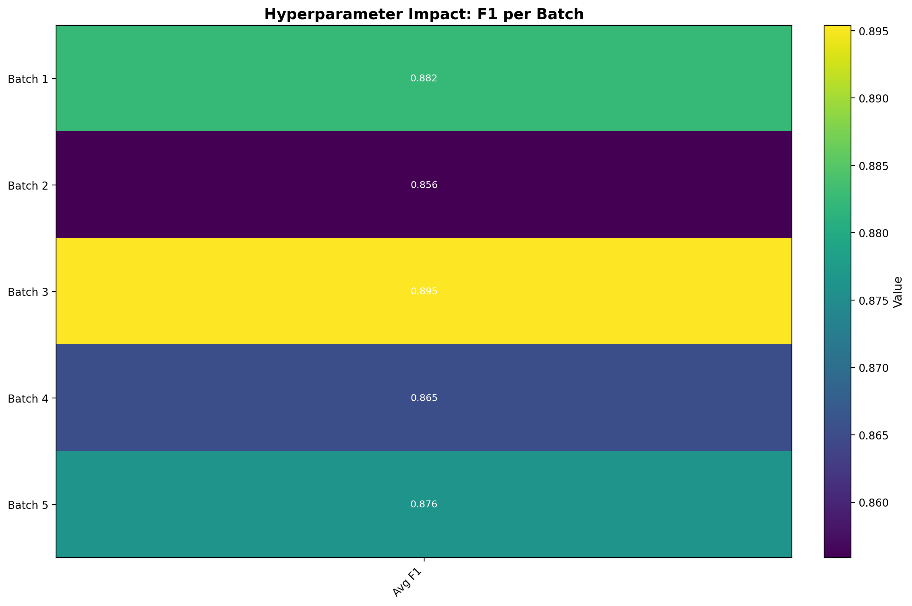

4. Detailed Run Summary Overview
Top 5 runs by F1 score:
Batch | Run Name | Accuracy | Precision | Recall | F1 Score | AUC | Loss
3 | run_4 | 0.915820638940861 | 0.8967267643929135 | 0.9093860166445541 | 0.9149906766980123 | 0.9483100459322601 | 0.19340266369179404
3 | run_2 | 0.915820638940861 | 0.8967267643929135 | 0.9295438301140682 | 0.9127843783415054 | 0.9295644759885316 | 0.1816404509389179
3 | run_1 | 0.9115503390921442 | 0.9286985084870074 | 0.9215691304301075 | 0.901940251850421 | 0.9316446026977819 | 0.20028426792567358
1 | run_1 | 0.895820638940861 | 0.8767267643929135 | 0.9095438301140681 | 0.8927843783415054 | 0.9095644759885316 | 0.1916404509389179
1 | run_5 | 0.895820638940861 | 0.8767267643929135 | 0.9095438301140681 | 0.8927843783415054 | 0.9095644759885316 | 0.1916404509389179

5. Statistical Analysis Summary
Global metrics:
accuracy: mean=0.882541701055032, std=0.01936455760358606, min=0.8484679644651406, max=0.915820638940861
precision: mean=0.8720270798086571, std=0.025589078274550536, min=0.8275905773618031, max=0.9286985084870074
recall: mean=0.8838412174386048, std=0.02557295703021548, min=0.8375596833560659, max=0.9295438301140682
f1_score: mean=0.8750673747926584, std=0.020588334352271184, min=0.8365456923370274, max=0.9149906766980123
auc: mean=0.8952261570377602, std=0.02783259496311161, min=0.8428684867309667, max=0.9483100459322601
latency: mean=9.411679826580286, std=1.4892998067497136, min=7.755605246773423, max=12.088238488239497
Confidence intervals:
accuracy: 0.8745484045381112 - 0.8905349975719529
precision: 0.8614644274398108 - 0.8825897321775035
recall: 0.8732852195923574 - 0.8943972152848522
f1_score: 0.8665689280614646 - 0.8835658215238522
auc: 0.8837374264956119 - 0.9067148875799085
latency: 8.796927080783561 - 10.026432572377011

6. Statistical Analysis Plots
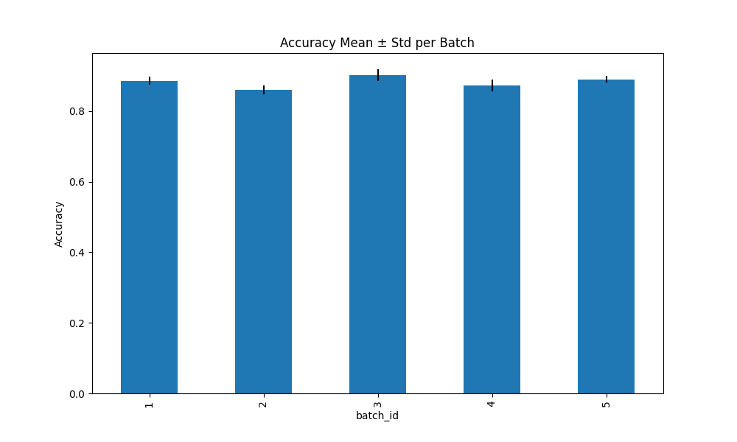

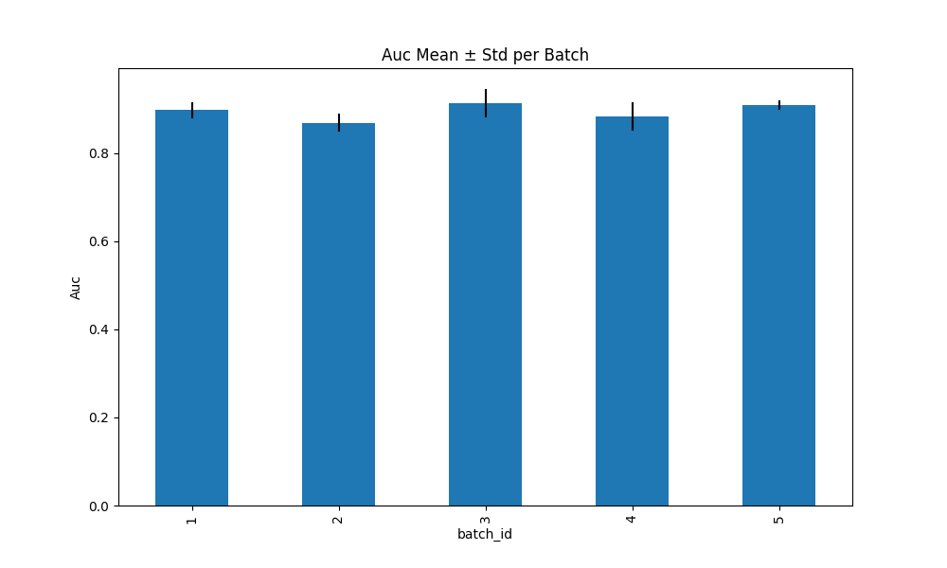

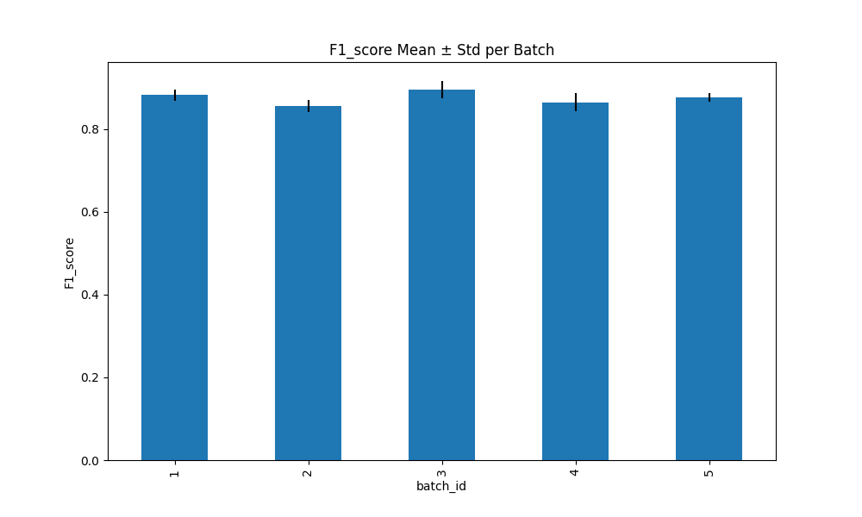

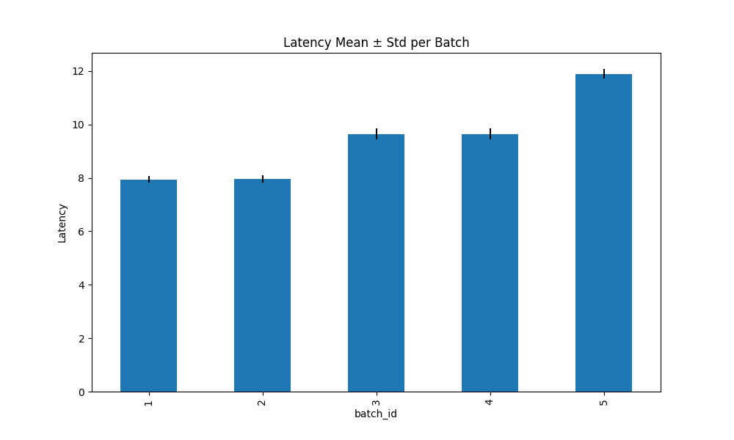

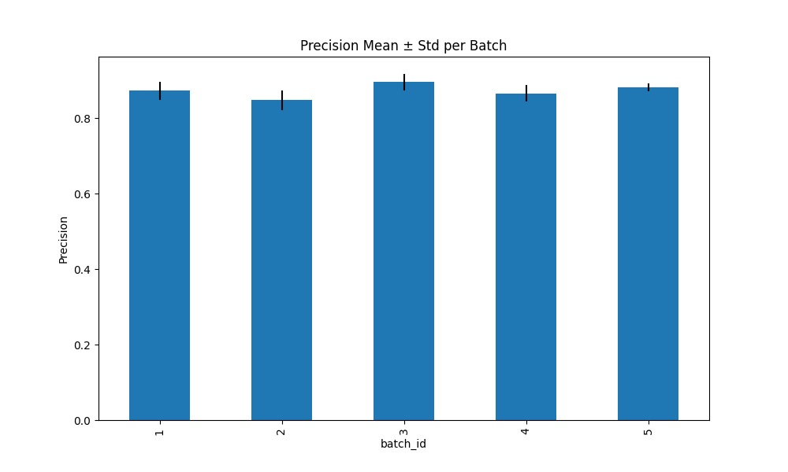

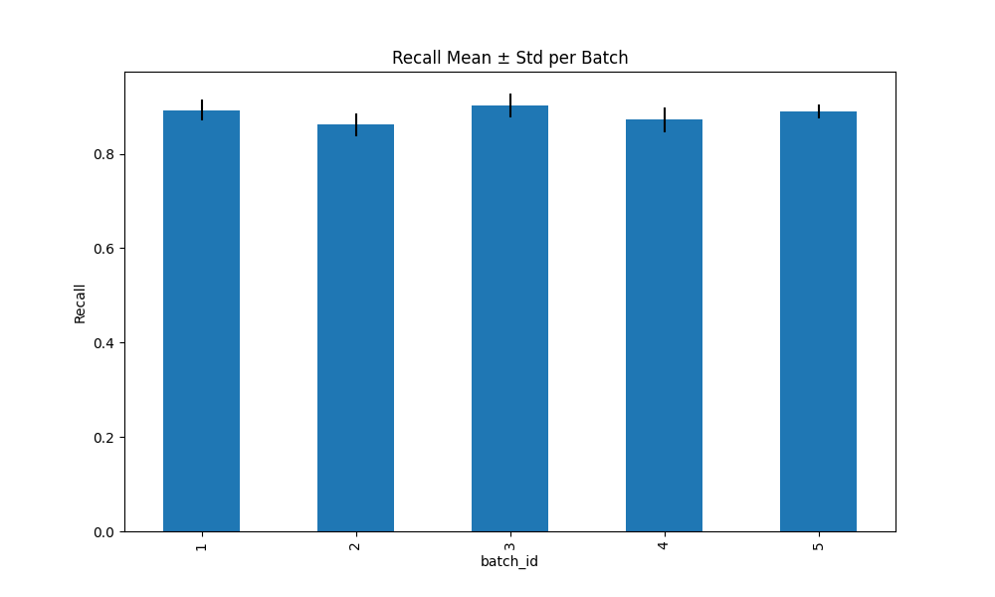

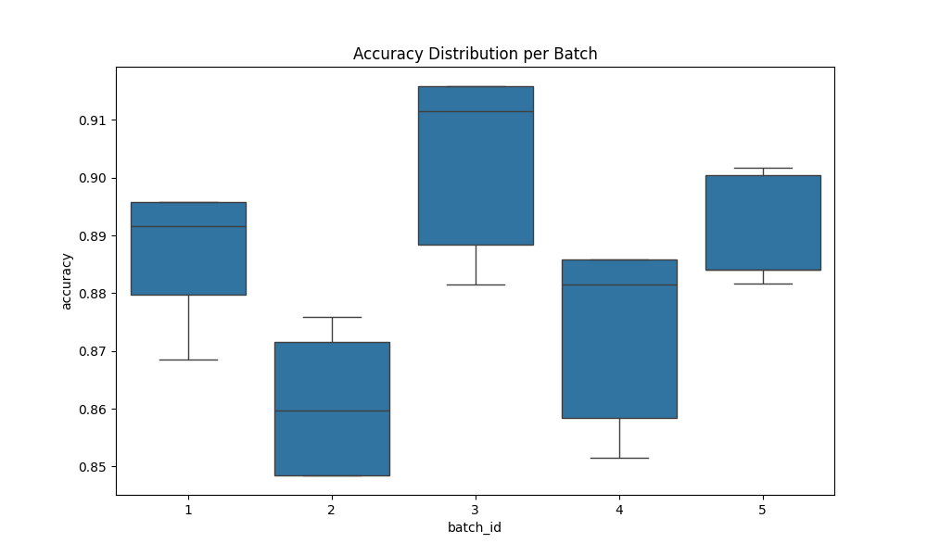

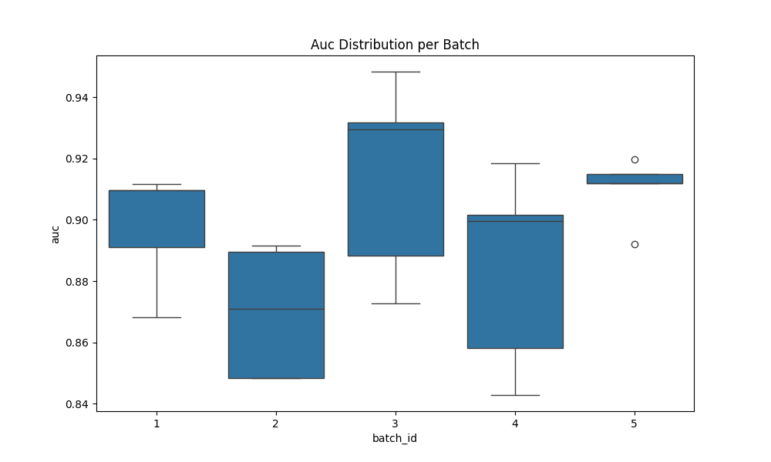

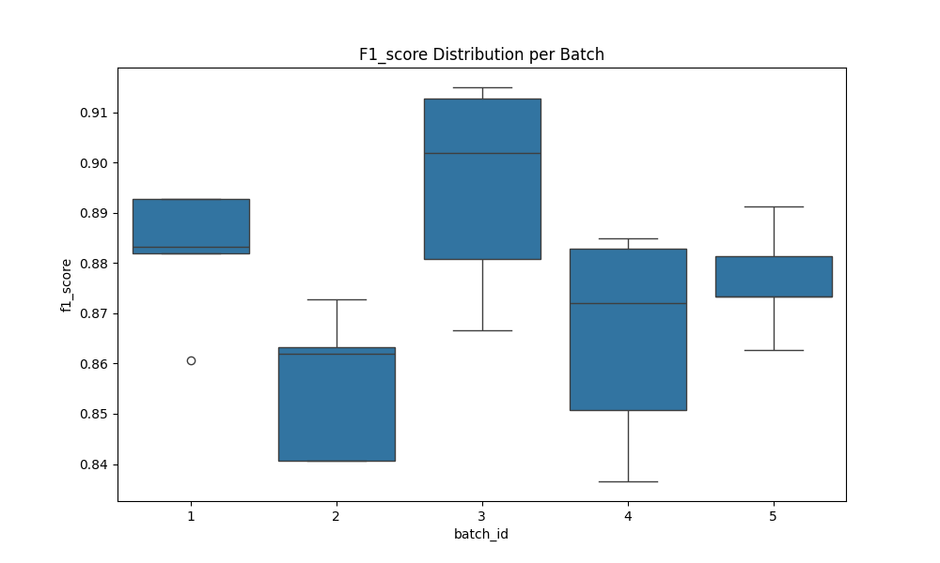

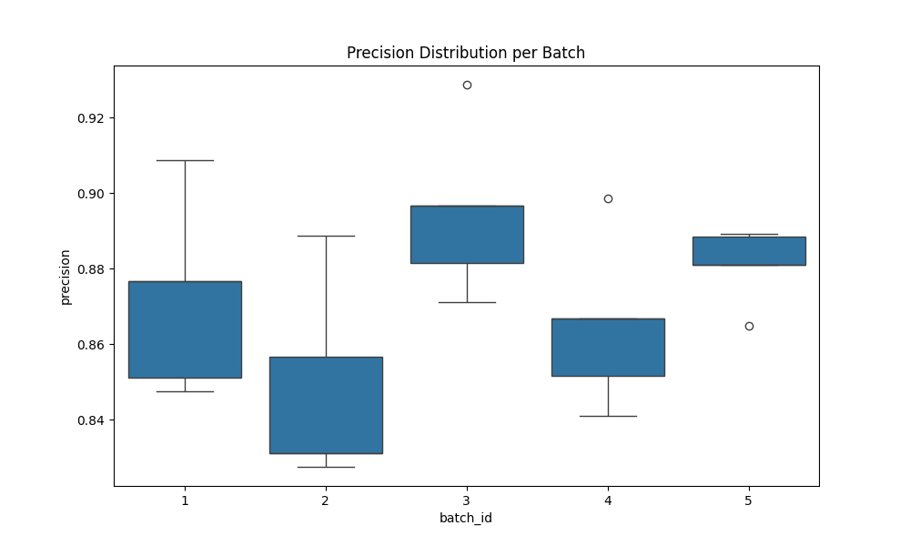

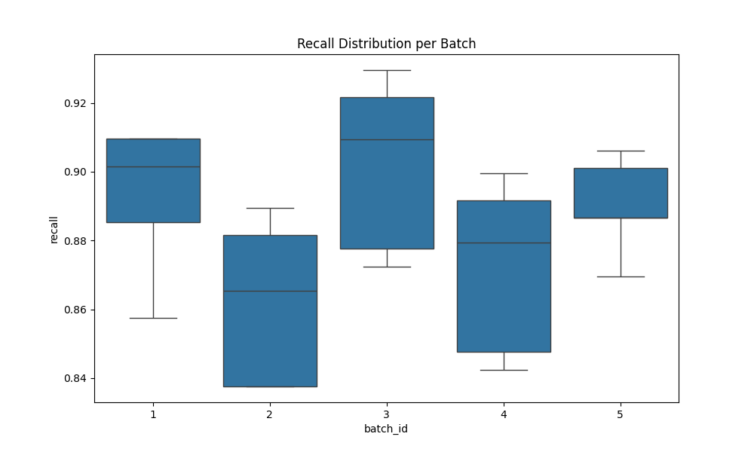

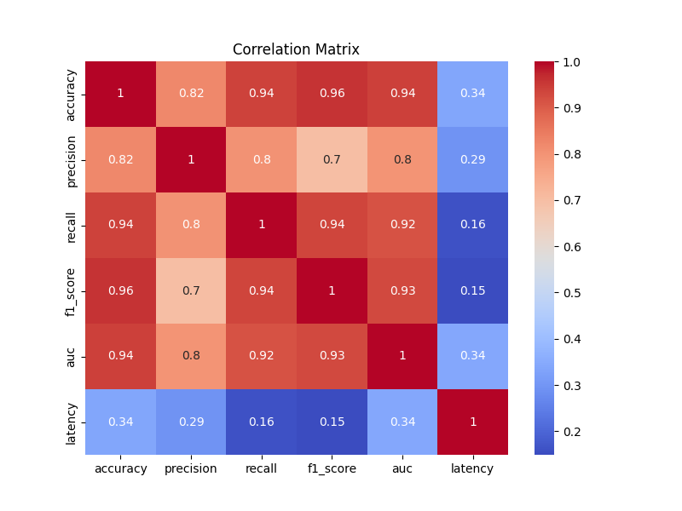

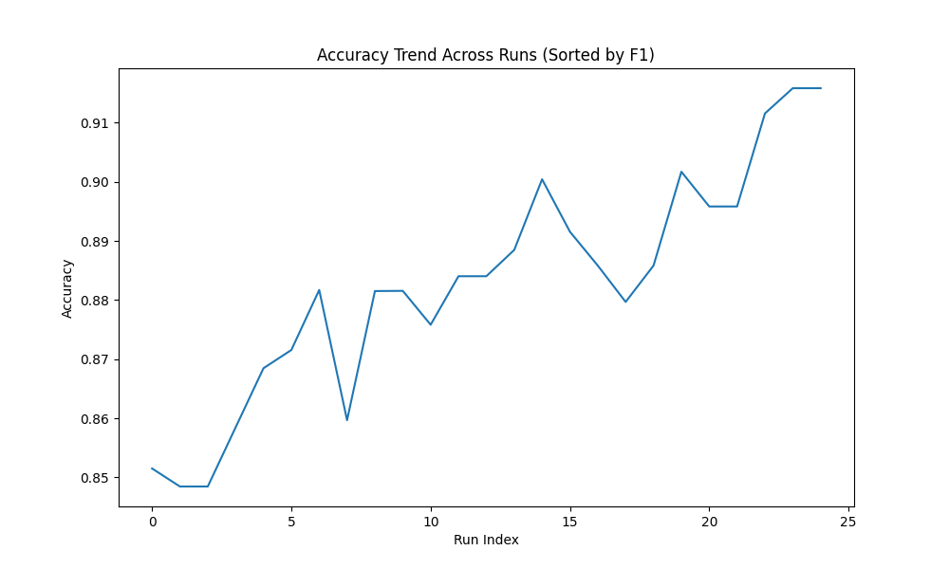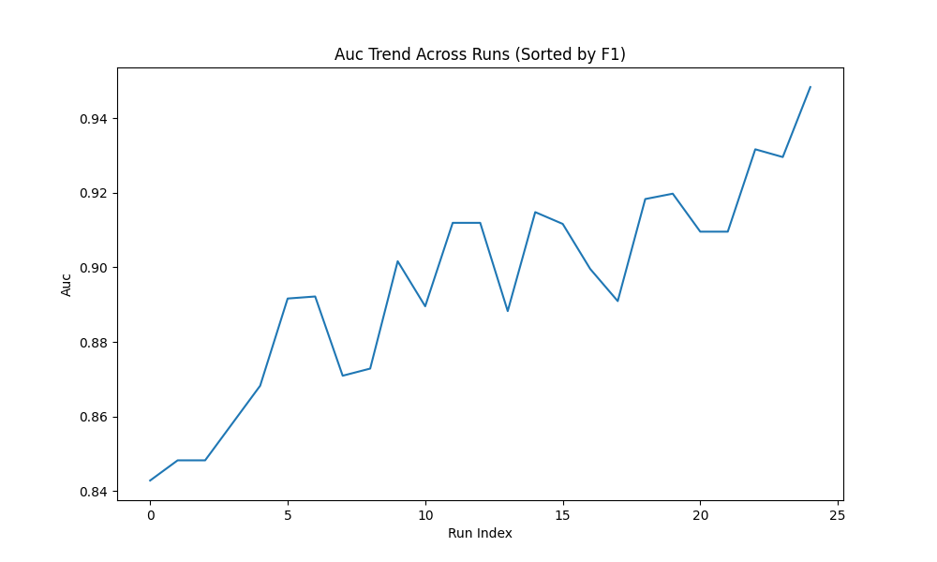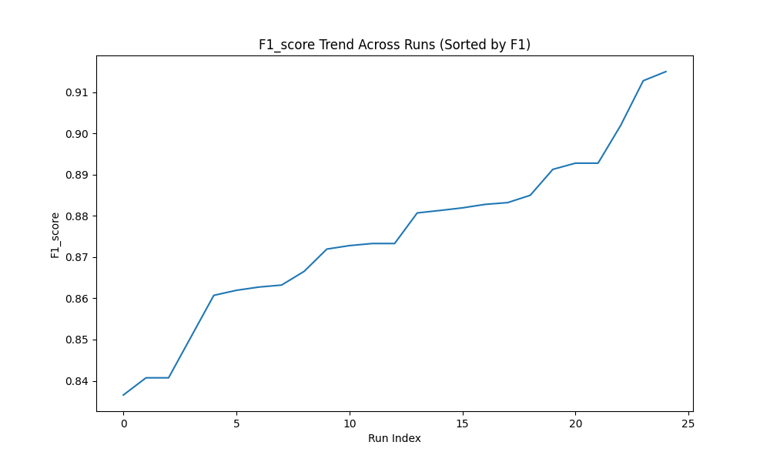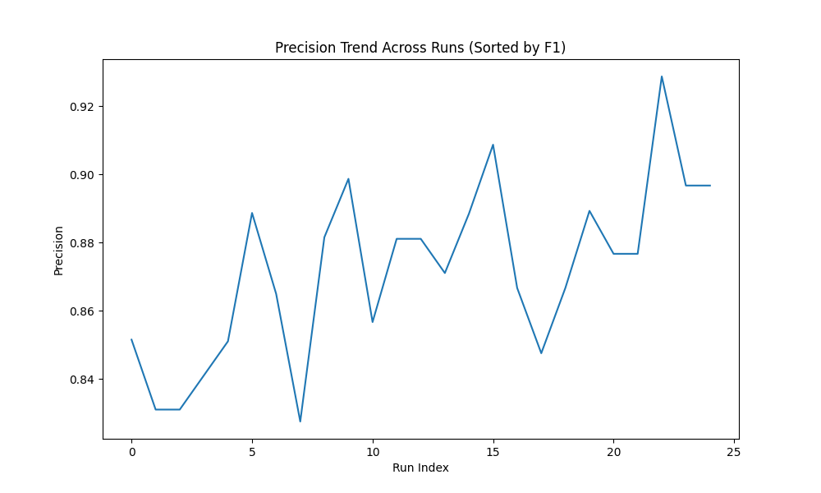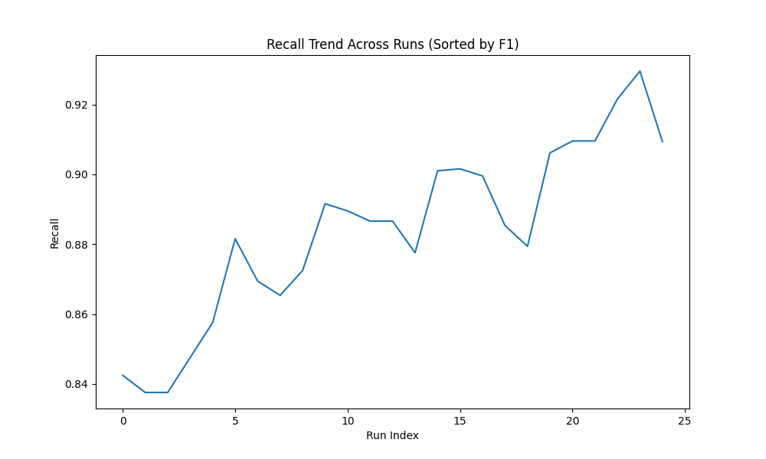

7. Key Insights & Analysis
• Best Performing Metric: LATENCY with mean 9.411680
• Most Stable Metric: ACCURACY with std 0.018973
• Highest Variance: LATENCY with variance 2.129293
• Best Run: Batch 3 Run run_4 with F1 0.914991
• Worst Run: Batch 4 Run run_5 with F1 0.836546
• Total evaluation samples: 150 across 5 batches

